# **Practical – 4**

**Aim: Practical 4: Write a program to compute summary statistics such as mean, median, mode, standard deviation and variance of the given different types of data.**

* Code:

import pandas as pd

import matplotlib.pyplot as plt

import numpy as np

data_set = pd.read_csv("/content/drive/MyDrive/temp/prac_4.csv")

df = pd.DataFrame(data_set)

# ! getting only int or flot data cols

num_data = df.select_dtypes(include=["int64", "float64"])

stats = {

"Mean": num_data.mean(),

"Median": num_data.median(),

"Mode": num_data.mode().iloc[0],

"Standard Deviation": num_data.std(),

"Variance": num_data.var()

}

state_table = pd.DataFrame(stats)

print("Result\n")

print(state_table)

fig, axes = plt.subplots(2, 2, figsize=(10, 8))

temp_state_table = state_table.drop(index = "Release Year", errors = "ignore")

temp_state_table2 = state_table.drop(index = "Active Players (millions)", errors = "ignore")

temp_table = num_data.drop(columns = "Release Year")

# ! Hist chart

axes[0, 0].hist(num_data, bins=5, edgecolor='black', alpha=0.7)

axes[0, 0].set_title("Histogram of Numerical Data")

axes[0, 0].set_xlabel("Value")

axes[0, 0].set_ylabel("Frequency")

# ! Box chart

temp_table.boxplot(ax=axes[0, 1])

axes[0, 1].set_title("Box Plot of Numerical Data")

axes[0, 1].set_xlabel("Columns")

axes[0, 1].set_ylabel("Value")

# ! Bar Plot graph

temp_state_table[["Mean", "Median", "Mode"]].plot(kind="bar", ax=axes[1, 0])

axes[1, 0].set_title("Comparison of Mean, Median, Mode")

axes[1, 0].set_ylabel("Value")

# ! Bar Plot

temp_state_table2[["Standard Deviation", "Variance"]].plot(kind="bar", ax=axes[1, 1])

axes[1, 1].set_title("Standard Deviation & Variance")

axes[1, 1].set_ylabel("Value")

plt.tight_layout()

plt.show()

* 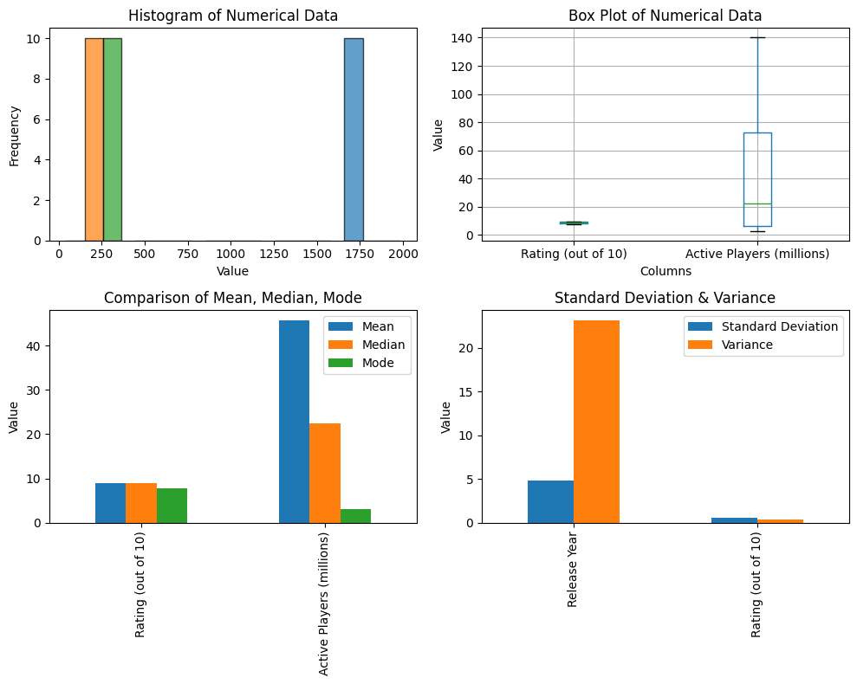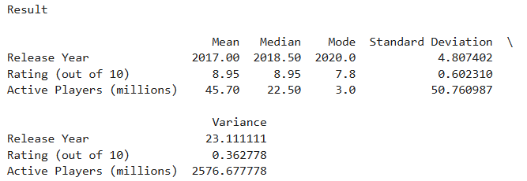Output:

Faculty Signature: _______________ Date: _____________________